sensor with IIC signal output
Designer's Reference Handbook
product description:
IIC signal output pressure sensor products are combined with advanced analog-digital mixed CMOS dedicated chips and high-schedule pressure cores .

Product Features :
➢ I ² C digital output
➢ High precision , good stability and high reliability
➢Stainless steel thread G1/4 (2 points) connection

typical application:
➢ IoT pressure collection
➢Medical electronics
➢Inflatable equipment
➢Consumer Electronics

Extreme conditions:
parameter | symbol | note | the smallest | typical | maximum | unit
supply voltage | VDD |  | -0.3 _ |  | 3.6 | V
Input Current | I _{IN} | input current to the pin | -100 |  | 100 | mA
storage temperature | T _{STOR} |  | -40 |  | 125 | ℃
Breaking pressure | P _{BREAK} | Depends on core type | 2x
ESD | V _{ESD} |  |  | ± 3.5 |  | KV

Working conditions:
parameter | symbol | note | the smallest | typical | maximum | unit
supply voltage | VDD |  | 1.8 | 3.3 | 3.6 | V
digital output | D _{test} |  | 0 |  | 16777215
Operating temperature | TOPR _ |  | -40 |  | 85 | ℃
Compensation temperature | T _{CPS} |  | 0 |  | 50 | ℃
pressure range | P _{RANGE} | Depends on core type | -11.25 |  | 1.25 | KPa

Other parameters :
parameter | symbol | note | the smallest | typical | maximum | unit
Maximum average current | Id _{max} | During continuous measurement |  |  | 0.6 | mA
stand-by current | Id _{stb} | Dormant state at 25°C |  |  | 0.1 | uA
I ² C clock frequency | fc _{I2C} |  |  |  | 3.4 | MHz
Measurement frequency | T _{CPS} |  | 5 |  | 100 | Hz

Input-output relationship:

$$Pressure=\frac{P_{MAX}-P_{MIN}}{D_{MAX}-D_{MIN}}·\left(D_{test}-D_{MIN}\right)+P_{MIN}$$

Pressure : actual pressure value ; D _{test} : digital output value of sensor ; P _{MIN} : sensor zero pressure value ; P _{MAX} : sensor full scale pressure value; D _{MIN} : corresponding digital output value at sensor zero point ; D _{MAX} : sensor full The corresponding digital output value in the range ;

Pin definition :
Lead color | electrical definition
black | Negative pole of power supply (GND)
red | Positive power supply (VDD), recommended value 3.3V
white | IIC clock (SCL)
yellow | IIC data (SDA)

The electrical connection between the sensor and the MCU:

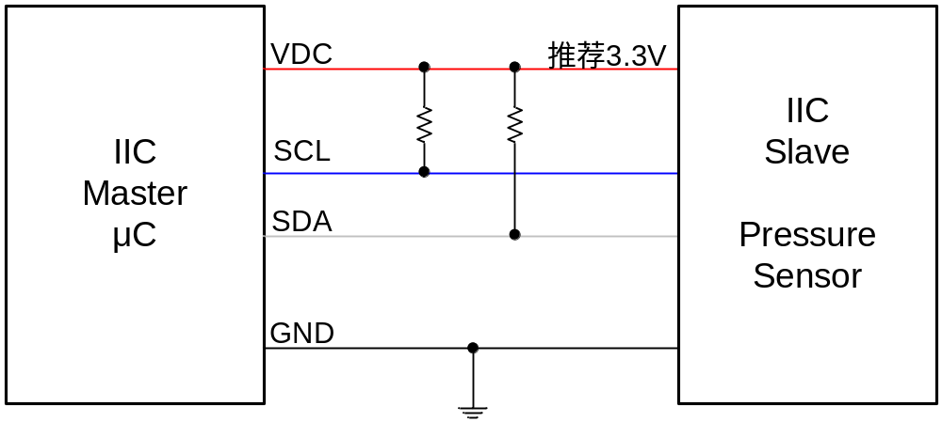

Note :
1) Prevent solid particles such as dust from entering the pressure guide hole.
2) Avoid using in corrosive gas and liquid.
3) It is recommended to add a filter capacitor between VDD and GND to resist power interference.
4) Avoid working near strong electromagnetic interference environments such as static electricity, lightning, and strong radio.
5) Avoid super strong vibration.
6 ) Avoid exceeding the index power supply and avoid reverse power supply.

I2C interface :
Write operation - start a measurement
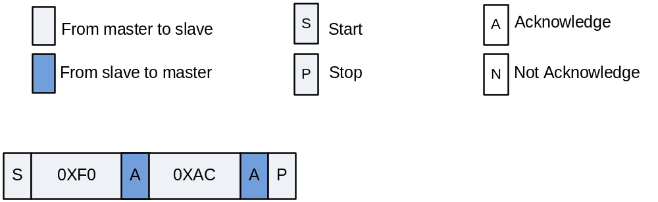Write command to start a measurement
0 xF 0 means the default 7bit s I 2 ^{C} sensor slave device address is 0x78, and the last 1 bit is 0 means the master device MCU writes to the slave device. 0xAC is the command word, which starts a measurement from the device sensor.

Wait for the measurement to end
After sending the write command, you need to wait for a period of time, wait for the end of the sensor measurement of the slave device, and then send the read command to read the measurement data.
To judge the end of the sensor measurement of the slave device, there are the following two detection methods besides delay waiting.
(1) Software query method - read status word
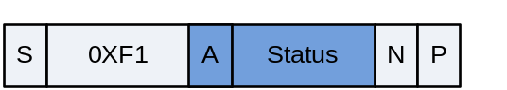
read status word
0 xF 1 means that the default 7bit s I 2 ^{C} sensor slave device address is 0x78, and the last 1 bit is 1 means that the master device MCU reads from the slave device, and the first byte read is the status word.

Table: Bit Description of the Status Word
bit _ | significance | describe
Bit7 | reserve | Fixed to 0
B it6 | Power indication _ _ _ | 1 The device is powered on (V _{DDB} on); 0 The device is powered off
B it5 | Busy indication _ | requested by the latest I ² C command is not valid yet. If the device is busy, new commands will not be processed.  0 indicates that the data requested by the last I ² C command is ready to be read
B it4 | reserve | Fixed to 0
Bit [3] | Working status (Mode Status) | - NOR mode  1 CMD mode
Bit2 | Memory Data Integrity Indication  ( Memory integrity/error flag) | 0 means the OTP memory data integrity test ( CRC ) passed,  1 indicates that the integrity test failed.  for data integrity is only calculated once during power-up ( POR ) , so the new CRC value being written is only available after the following POR.
Bit1 | reserve | Fixed to 0
Bit0 | reserve | Fixed to 0

- Hardware Judgment Method - EOC Identification or Interruption
After starting the measurement, EOC becomes low level "0"; after the measurement ends, EOC becomes high level "1".
Read the pressure value
S
0XF1
A
Status
N
P
A
BridgeDat
[
23
:
16
]
A
BridgeDat
[
15
:
8
]
A
BridgeDat
[
7
:
0
]
A
TempDat
[
15
:
8
]
A
TempDat
[
7
:
0
]
I ² C read out 5 bytes of calibrated bridge and temperature values
0 xF 1 means the default 7bit s I 2 ^{C} sensor slave device address is 0x78, the last 1bit is 1 means the master device MCU reads the slave device, the first byte read is the status word, and then read is the pressure value of three bytes.
Sleep standby
After the sensor completes the measurement, it enters the sleep standby state, and the standby power consumption is 0.1uA.
Example of pressure conversion:
After reading the calibration data, it is necessary to perform a simple conversion of the unsigned number represented by the AD value.
For the convenience of understanding, we assume that the calibration data read is: 0x04 0x9B 0xB0 0xC5 0x56 0xAA
0x04 is the status word, Bit 5 is 1, indicating that the latest I ² C is busy, and it needs to wait for a while. If Bit 5 is 0 , it means that the device is not busy and can read data. For a detailed description of each bit of the status word, please refer to the appendix.
0x9B 0xB0 0xC5 three bytes are bridge calibration value
0x56 0xAA Two bytes are the temperature calibration value
Bridge calibration value conversion : convert 0x9B 0xB0 0xC5 to decimal number 10203333 ,
1. This calculation assumes that the range used for calibration is 0 Kpa- 100 0Kpa, and the corresponding AD output is 1677722~15099494 (10%AD~90%AD)
According to the calibration formula of P2 input-output relationship:
Actual pressure value = (1 00 0 -0) / (15099494-1677722) * ( 10203333- 1677722) + 0 = 635.2076 Kpa

2. This calculation assumes that the range used for calibration is 0 Kpa- 160 0Kpa, and the corresponding AD output is 1677722~15099494 (10%AD~90%AD)
According to the calibration formula of P2 input-output relationship:
Actual pressure value = (1 60 0 -0) / (15099494-1677722) * ( 10203333- 1677722) + 0 = 1016.332 Kpa

Temperature calibration value conversion : convert 0x56 0xAA to decimal number 22186 , since the read calibration data is expressed in percentage form, this percentage is numerically equal to the maximum value of the converted decimal number and 16 bits unsigned number (65535 ) ratio, so the following calculations can be performed when converting percentages
22186 / 65536*100%=33.85%
The temperature calibration range is specified as - 40 ℃ - 150 ℃ , so the calibration value = ( 150 - (- 40)) * 33.85% - 40 = 24.32 ℃
Note: The temperature of the medium used by this sensor is recommended to be lower than 50 degrees, so the temperature has no reference value.

